CONSTRUCTION OF DFA: IN TYPE-01 PROBLEMS
Step-01:
Determine the minimum number of states required in the DFA.
Draw those states.
RULE
Calculate the length of substring.
All strings ending with ‘n’ length substring will always require minimum (n+1) states in the DFA.
Step-02:
Decide the strings for which DFA will be constructed.
RULE
While constructing a DFA,
Always prefer to use the existing path.
Create a new path only when there exists no path to go with.
Step-03:
Construct a DFA for the strings decided in Step-02.
Step-04:
Send all the left possible combinations to the starting state.
Do not send the left possible combinations over the dead state.

PRACTICE PROBLEMS BASED ON CONSTRUCTION OF DFA

Problem-01:

Draw a DFA for the language accepting strings ending with ’01’ over input alphabets ∑ = {0, 1}

Solution-

Regular expression for the given language = (0 + 1)*01
Step-01:
All strings of the language ends with substring “01”.
So, length of substring = 2.
Thus, Minimum number of states required in the DFA = 2 + 1 = 3.

It suggests that minimized DFA will have 3 states.

Step-02:

We will construct DFA for the following strings-

01
001
0101

Step-03:

The required DFA is-

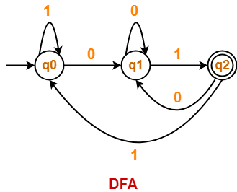

Problem-02:

Draw a DFA for the language accepting strings ending with ‘abb’ over input alphabets ∑ = {a, b}

Solution-

Regular expression for the given language = (a + b)*abb

Step-01:

All strings of the language ends with substring “abb”.
So, length of substring = 3.

Thus, Minimum number of states required in the DFA = 3 + 1 = 4.
It suggests that minimized DFA will have 4 states.

Step-02:

We will construct DFA for the following strings-

abb
aabb
ababb
abbabb

Step-03:

The required DFA is-

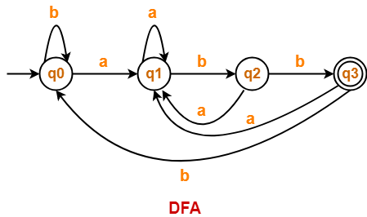

Problem-03:

Draw a DFA for the language accepting strings ending with ‘abba’ over input alphabets ∑ = {a, b}

Solution-

Regular expression for the given language = (a + b)*abba

Step-01:

All strings of the language ends with substring “abba”.
So, length of substring = 4.

Thus, Minimum number of states required in the DFA = 4 + 1 = 5.

It suggests that minimized DFA will have 5 states.

Step-02:

We will construct DFA for the following strings-

abba
aabba
ababba
abbabba
abbaabba

Step-03:

The required DFA is-

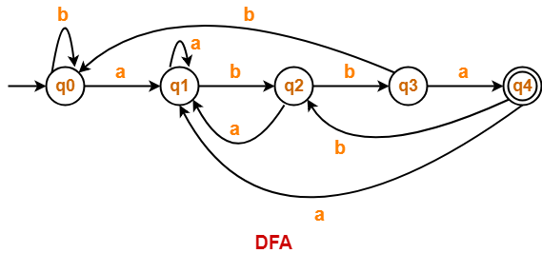

Problem-04:

Draw a DFA for the language accepting strings ending with ‘0011’ over input alphabets ∑ = {0, 1}

Solution-
Regular expression for the given language = (0 + 1)*0011

Step-01:

All strings of the language ends with substring “0011”.
So, length of substring = 4.

Thus, Minimum number of states required in the DFA = 4 + 1 = 5.

It suggests that minimized DFA will have 5 states.

Step-02:
We will construct DFA for the following strings-

0011
00011
000011
0010011
00110011

Step-03:

The required DFA is-

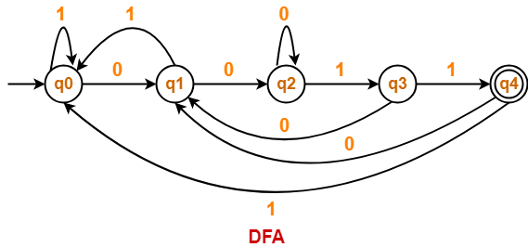

CONSTRUCTION OF DFA: IN TYPE-02 PROBLEMS

In Type-02 problems, we will discuss the construction of DFA for languages consisting of strings starting with a particular substring.

Steps to Construct DFA

Following steps are followed to construct a DFA for Type-02 problems.
Step-01:
Determine the minimum number of states required in the DFA.
Draw those states.
Calculate the length of substring.
All strings starting with ‘n’ length substring will always require minimum (n+2) states in the DFA.
PRACTICE PROBLEMS BASED ON CONSTRUCTION OF DFA
Problem-01:
Draw a DFA for the language accepting strings starting with ‘ab’ over input alphabets ∑ = {a, b}
Solution-
Regular expression for the given language = ab(a + b)*
Step-01:
All strings of the language starts with substring “ab”.
So, length of substring = 2.
Thus, Minimum number of states required in the DFA = 2 + 2 = 4.
It suggests that minimized DFA will have 4 states.
Step-02:
We will construct DFA for the following strings-
ab
aba
abab

Step-03:
The required DFA is-
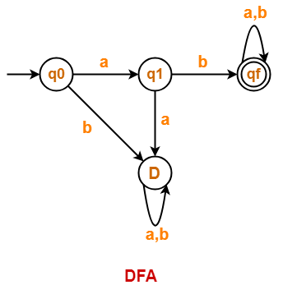
Problem-02:
Draw a DFA for the language accepting strings starting with ‘a’ over input alphabets ∑ = {a, b}
Solution-
Regular expression for the given language = a(a + b)*

Step-01:

All strings of the language starts with substring “a”.
So, length of substring = 1.
Thus, Minimum number of states required in the DFA = 1 + 2 = 3.
It suggests that minimized DFA will have 3 states.

Step-02:
We will construct DFA for the following strings-
a
aa

Step-03:
The required DFA is-
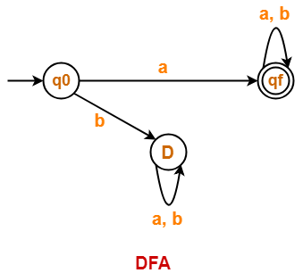
Problem-03:

Draw a DFA for the language accepting strings starting with ‘101’ over input alphabets ∑ = {0, 1}

Solution-

Regular expression for the given language = 101(0 + 1)*

Step-01:

All strings of the language starts with substring “101”.
So, length of substring = 3.

Thus, Minimum number of states required in the DFA = 3 + 2 = 5.
It suggests that minimized DFA will have 5 states.

Step-02:
We will construct DFA for the following strings-

101
1011
10110
101101

Step-03:
The required DFA is-

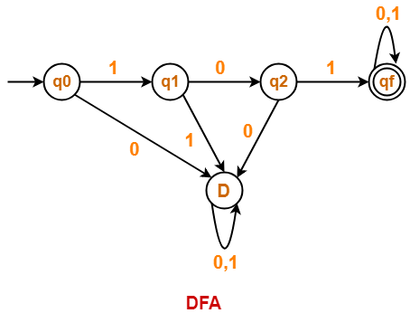

Problem-04:

Draw a DFA that accepts a language L over input alphabets ∑ = {0, 1} such that L is the set of all strings starting with ’00’.

Solution-
Regular expression for the given language = 00(0 + 1)*

Step-01:

All strings of the language starts with substring “00”.
So, length of substring = 2.

Thus, Minimum number of states required in the DFA = 2 + 2 = 4.

It suggests that minimized DFA will have 4 states.

Step-02:

We will construct DFA for the following strings-
00
000
00000

Step-03:

The required DFA is-
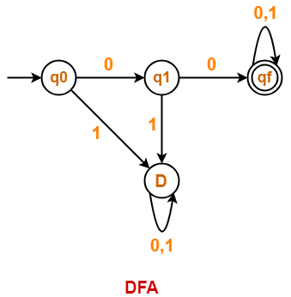

Problem-05:

Construct a DFA that accepts a language L over input alphabets ∑ = {a, b} such that L is the set of all strings starting with ‘aa’ or ‘bb’.

Solution-

Regular expression for the given language = (aa + bb)(a + b)*

Step-01:

Minimum number of states required in the DFA = 5.
It suggests that minimized DFA will have 5 states.
Step-02:

We will construct DFA for the following strings-
aa
aaa
aaaa
bb
bbb
bbbb

Step-03:

The required DFA is-

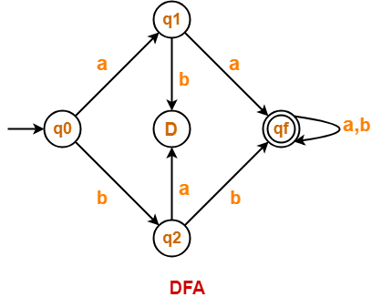

Problem-06:
Construct a DFA that accepts a language L over input alphabets ∑ = {a, b} such that L is the set of all strings starting with ‘aba’.
Solution-
Regular expression for the given language = aba(a + b)*
Step-01:
All strings of the language starts with substring “aba”.
So, length of substring = 3.
Thus, Minimum number of states required in the DFA = 3 + 2 = 5.
It suggests that minimized DFA will have 5 states.
Step-02:
We will construct DFA for the following strings-
aba
abaa
abaab
abaaba
Step-03:
The required DFA is-
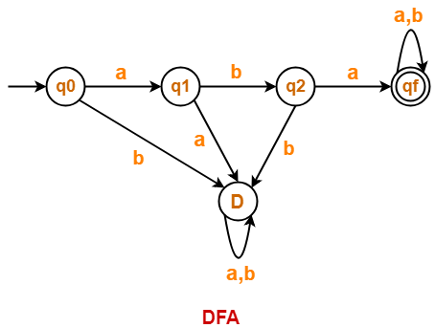

Problem – Contruct a DFA machine over input alphabet = {0, 1}, that accepts:
- Odd number of 0’s or even number of 1’s
- Odd number of 0’s and even number of 1’s
- Either odd number of 0’s or even number of 1’s but not the both together
Solution – Let first design two separate machines for the two conditions:
- Accepting only odd number of 0’s
- Accepting only even number of 1’s
Then, merge these two and find the required final states.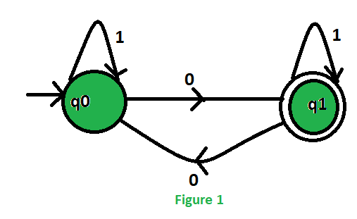
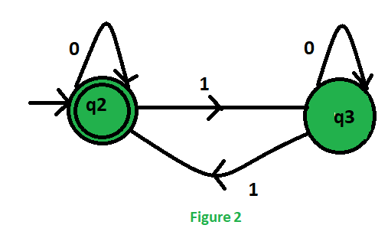
To merge these two machines, we will take the Cartesian product of the states of these two machines:
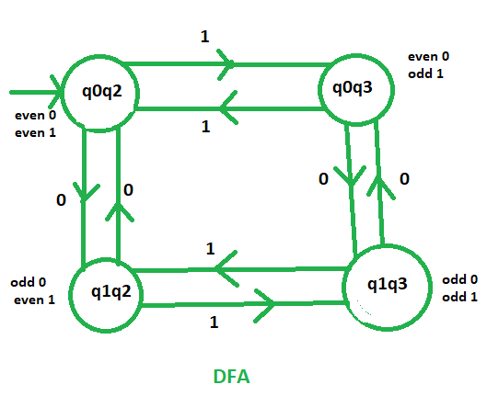
Initial state of these DFA will be the state which contains the initial states of those two separate machines. As, q0 and q2 are the initial states thus, q0q2 is the initial state of the final DFA.

Now start designing all the DFAs one by one:
- Odd number of 0’s or even number of 1’s:
This machine accept that languages which contains either odd no. of 0’s or even no. of 1’s. As we know that q1 indicates odd no. of 0’s and q2 indicates even no. of 1’s. So, the final states of the required DFA will contain either q1 or q2.
.’. Final states = {(q0q2), (q1q2), (q1q3)}
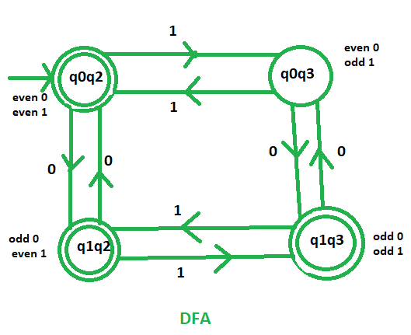
This is our required DFA which accept the languages containing odd no. of 0’s or even no. of 1’s.
- Odd number of 0’s and even number of 1’s:
This machine accept that languages which contains odd no. of 0’s and even no. of 1’s. As we know that q1 indicates odd no. of 0’s and q2 indicates even no. of 1’s. So, the final states of the required DFA will contain both q1 and q2.
.’. Final state = {(q1q2)}
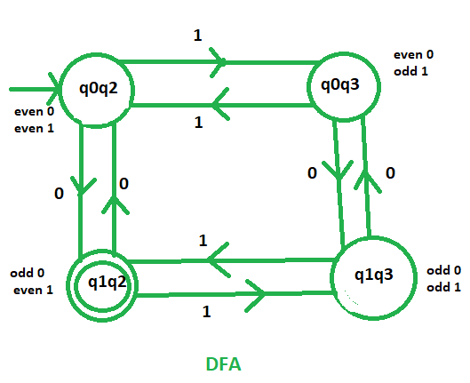
This is our required DFA which accept the languages containing odd no. and 0’s or even no. of 1’s.
- Either odd number of 0’s or even number of 1’s but not the both together:
This machine accept that languages which contains either odd no. of 0’s or even no. of 1’s but not that languages which contains both odd no. of 0’s and even no. of 1’s. As we know that q1 indicates odd no. of 0’s and q2 indicates even no. of 1’s. So, the final states of the required DFA will contain exactly one among q1 and q2.
.’. Final states = {(q0q2), (q1q3)}
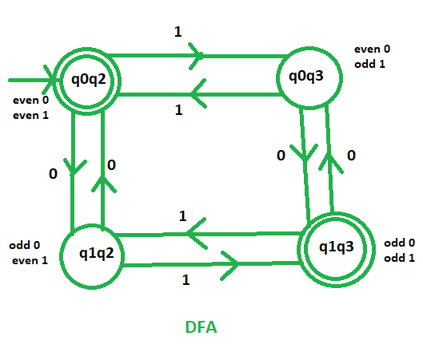
This is our required DFA which accept the languages containing odd no. of 0’s or even no. of 1’s but not the both together.

Examples from [1]:
1) Construct a DFA to accept a string containing a zero followed by a one.
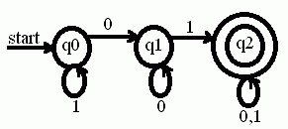
2) Construct a DFA to accept a string containing two consecutive zero’s followed by two consecutive ones.
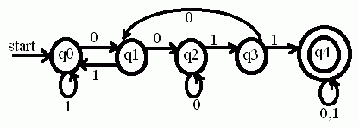
3) Construct a DFA to accept a string containing even number of zeros and any number of ones.
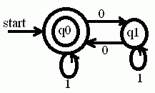
4) Construct a DFA to accept all stings which do not contain three consecutive zeros.
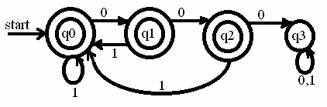
5) Construct a DFA to accept all strings containing even number of zeros and even number of ones.
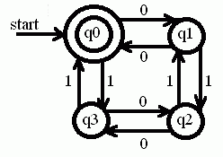
6) Construct a DFA to accept all strings which satisfy #(x)mod5=2.
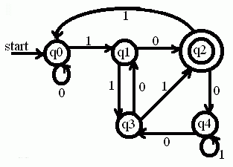
7) Construct a DFA to accept all strings (0+1)* with an equal number of zeros and ones such that each prefix has at most one more zero than ones and at most one more one than zeros.
